PROJECT REPORT

Project Title: Python Semester-1 Group Project

Project Name: Snake Game

Group: Python Lab Group-4 Team-4

Mentor TA: Lubaina Machinewala

Group Members:

|  |  |
| --- | --- |
| ***Roll Number*** | ***Name*** |
| IMT2020114 | Puram Rahul Kumar Reddy |
| IMT2020116 | Bhavjyot Singh Chadha |
| IMT2020120 | Sougandh Krishna K S |
| IMT2020127 | Dharmin Mehta |
| IMT2020134 | Ganga Sagar Reddy Kataru |

1. **ABSTRACT:**

This project is strictly based on the use of the computer language called Python. The project encapsulates on our present knowledge of the language and also exploring some of the wide aspects of the language like the usage of different modules, functions and implementing the GUI to the language.

The project is called the “Snake Game”. This is a game created by us using the different modules of Python, like PyGame and Random.

The game basically serves both the purpose of fun and challenge.

1. **SYSTEM REQUIREMENTS:**

* OS: 64-bit Windows 7 or later or OS X 10.11 or later.
* Processor: 1.5GHz or faster.
* Memory: 4GB (4,096MB) RAM.
* Free HDD space: 3GB.
* Hardware: Keyboard, mouse, headset.
* Programming Language: Python interpreter, version 3.7.7 or above. This version is recommended to enable seamless usage of necessary Python modules needed during development of the project.
* Coding Environment: We recommend the use of an IDE. It provides comprehensive facilities to programmers for software development. An IDE normally consists of at least a source code editor, build automation tools and a debugger. Microsoft Visual Studio Code or equivalent IDE on Linux-based Distribution can be used.
* How to run IDEs on Debian/Ubuntu based distributions:

The easiest way to install Visual Studio Code for Debian/Ubuntu based distributions is to download and install the .deb package (64 bit), either through the graphical software centre if it's available.

* Version Control: Version control, also known as source control, is the practice of tracking and managing changes to software code. Version control systems are software tools that help software teams manage changes to source code over time.
* We also recommend the use of GitHub or any equivalent platforms to make the collaboration of project between members easier.

1. **PROJECT DESCRIPTION**

* Specifications:

1. The game consists of a snake which moves in the entire screen of the monitor and is controlled by the arrow keys for movement.

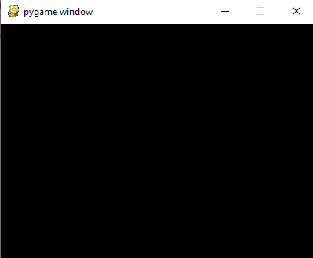

1. The snake moves towards left, right, up, down with these controls.

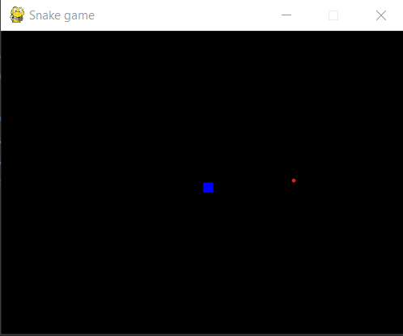

1. Another thing present in the game layout would be a small object depicted as ‘FOOD’.

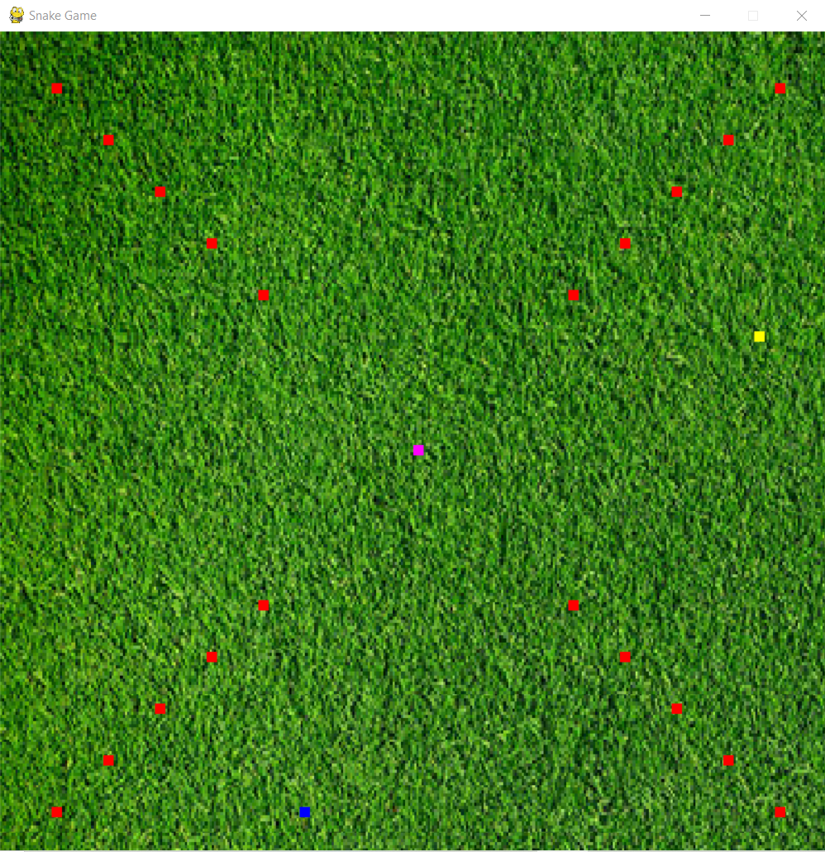

1. The ‘FOOD’ present in the game layout will help the snake grow in length and also increase the speed of movement of the snake with every food intake.

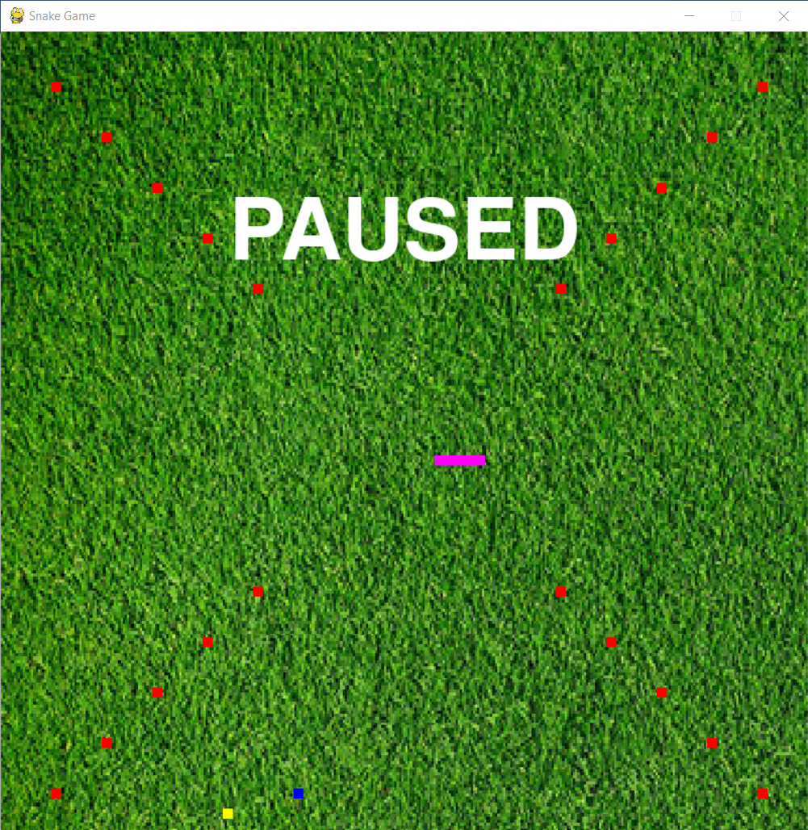

1. Upon having the food intake, the user will increase his/her score which will be displayed at the end of the game.
2. Touching the boundaries of the screen will make you ‘LOSE’ the game.

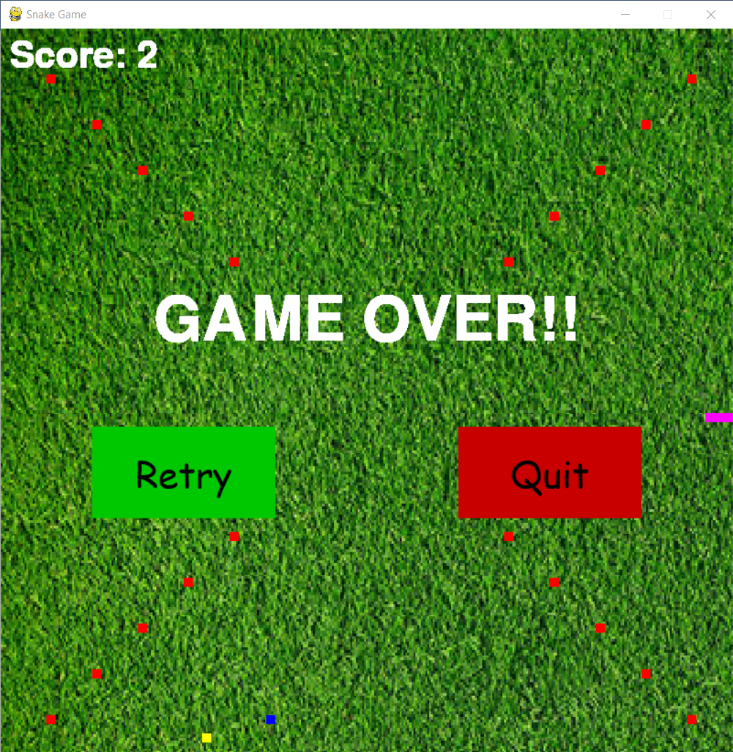

1. The game also has some obstacles placed in it which are displayed in RED color.
2. When the snake touches any of these obstacles during its movement, the user LOSES the game.

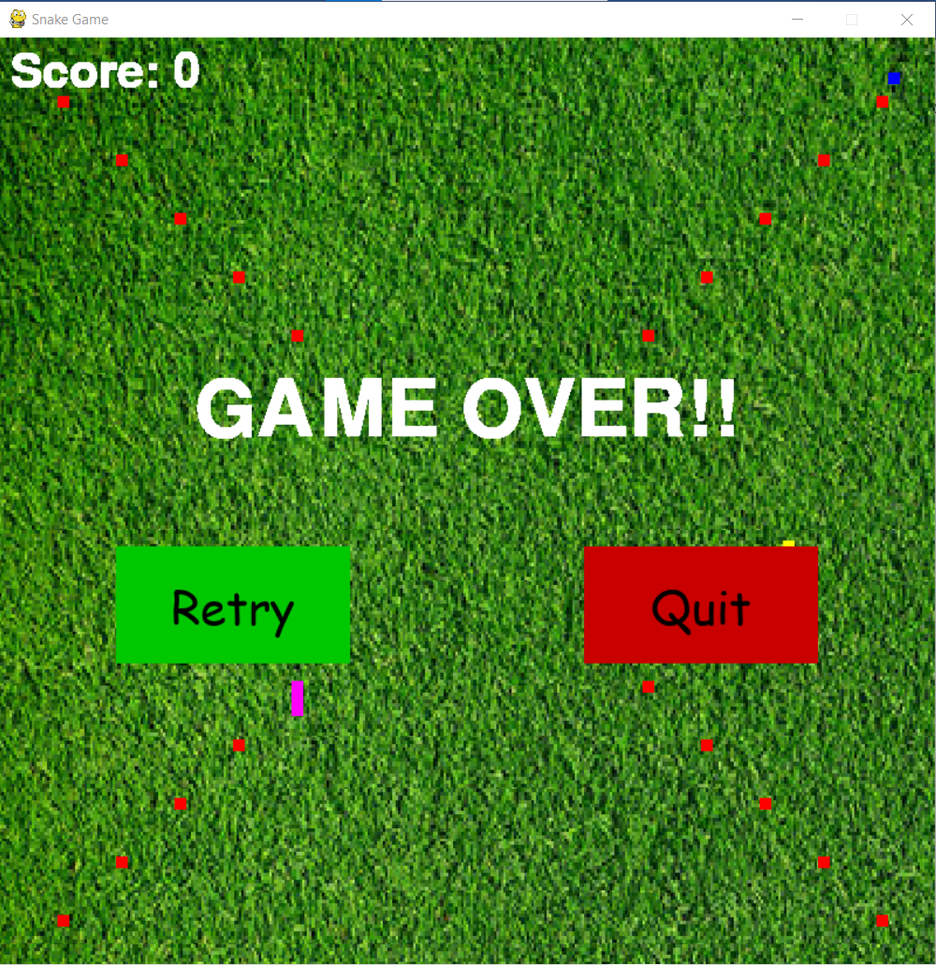

1. We have also included the presence of ‘poison’ which when eaten causes the length to decrease each time.

J) We also have included an Instruction page at the beginning of the Game.

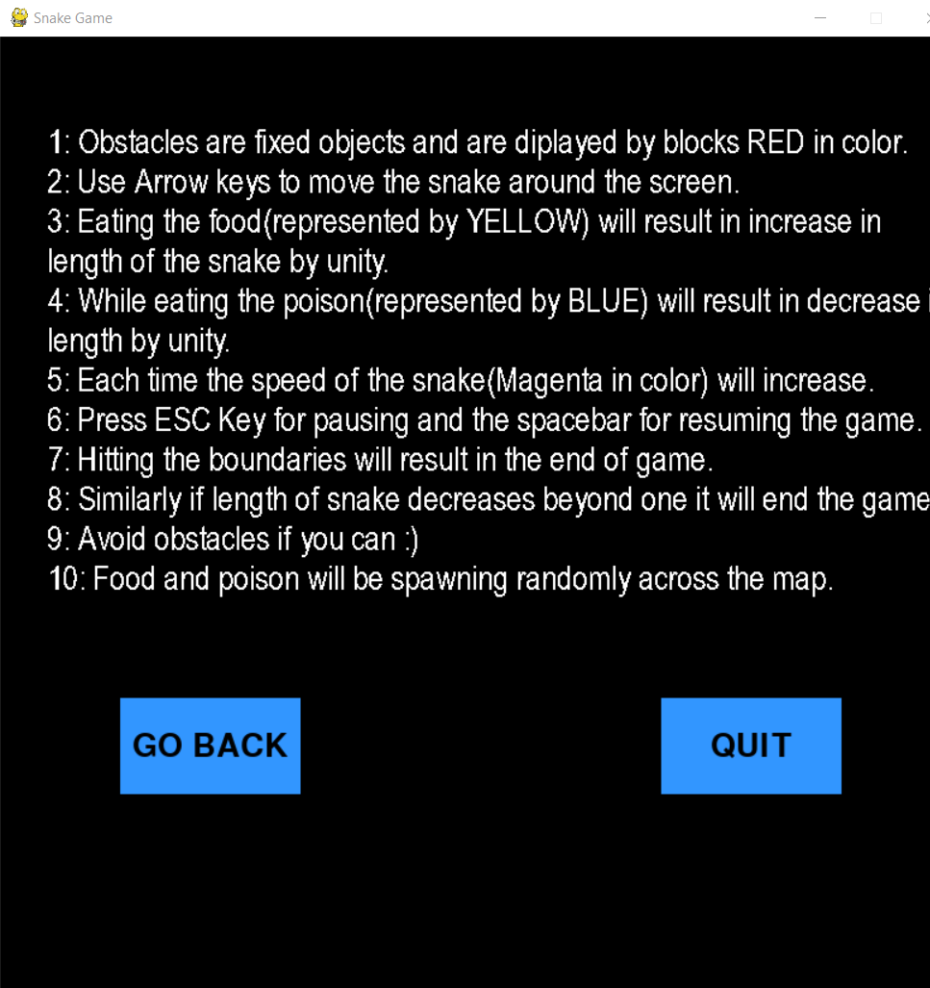

* Modules used:

The game uses the import of the modules named ‘pygame’ and ‘random’. The functions present in these modules are used for the making of the Game.

1. PyGame: PyGame is a cross-platform Python module used in IDEs to design Python based video games. It also includes computer graphics and sound libraries designed to be used with Python.
2. Random Module: Random module is another inbuilt module available in Python. It is used to generate pseudo-random variables. Here we make the use of Random Module for the appearance of the ‘FOOD’ at random points in the game
3. **Future Aspects:**

The future aspects of the game include our aim to make the game more and more compatible with as many softwares as possible and working on several machines. We also aim at improving the smoothness of the game by using python to a more comprehensive extent. The game is also intended to be fun and challenging at the same time. We also intend to add more graphics to the game and make the game graphically more appealing than before. This should be implemented by inclusion of GPU in the developing environment. We aim at providing a realistic experience to the users. Some of these motives will be achieved by for example making the use of a real-looking snake, the food being replaced by some actual fruit and the obstacles being replaced by trees or bushes or some large rocks.

1. **REFRENCES:**

<https://www.guru99.com/date-time-and-datetime-classes-in-python.html>

<https://www.pygame.org/news>

<https://realpython.com/pygame-a-primer/>

<https://www.atlassian.com/git/tutorials/what-is-version-control>

<https://en.wikipedia.org/wiki/Integrated_development_environment>

<https://support.enthought.com/hc/en-us/articles/204273874-Enthought-Python-Minimum-Hardware-Requirements>

<https://code.visualstudio.com/docs/setup/linux>

<https://en.wikipedia.org/wiki/Ubuntu>

Add Poison

Start:

Increase/Decrease Length of snake/Add Condition for presence of Obstacles

Create the Snake

Add Obstacles

While Game Does not finish

Add Food

End

Adding Movement to the snake

Display Game Screen

GAME LOOP